

Lab Journal: 02
Date: 9/27/2025

Student : Lotfullah Muslimwal
Enrollment : 01-131232-039

Department of Software Engineering

Bahria University, Islamabad

Software Construction-Lab (Fall-2025)
Teacher: ENGR. SAAD MAZHAR

Task No: | Task Wise Marks |  | Documentation Marks |  | Total Marks  (20)
Task No: | Assigned | Obtained | Assigned | Obtained | Total Marks  (20)
1 | 3 |  | 5
2 | 3 |  | 5
3 | 3 |  | 5
4 | 3 |  | 5
5 | 3 |  | 5

Comments:

Signature

Lab No: 03 - Lab Title: Java Lab 3

GitHub Repo: Lab 3 Code

Task 1: Building the Ticket Machine

Code for Task 1
import java.util.Scanner;

public class Main {
private String[] routes = {"City A to City B", "City B to City C", "City C to City A"};
private double[] prices = {5.0, 7.5, 6.0};
private double totalMoneyCollected = 0.0;
private double currentBalance = 0.0;

public Main() {
System.out.println("Welcome to the Ticket Machine!");
System.out.println("Available routes: ");
for (int i = 0; i < routes.length; i++) {
System.out.println(" " + (i + 1) + ". " + routes[i] + " - $" + prices[i]);
}
System.out.println();
}

public double checkBalance() {
return currentBalance;
}

public void insertMoney(double amount) {
if (amount > 0) {
currentBalance += amount;
System.out.println("Inserted $" + amount + ". Current balance: $" + currentBalance);
} else {
System.out.println("Please insert a valid amount!");
}
}

public double calculateTotalCost(int routeIndex, int quantity) {
if (routeIndex >= 0 && routeIndex < routes.length && quantity > 0) {
return prices[routeIndex] * quantity;
} else {
System.out.println("Invalid route or quantity!");
return 0.0;
}
}

public void printTicket(int routeIndex, int quantity) {
double totalCost = calculateTotalCost(routeIndex, quantity);
if (totalCost == 0) {
return;
}
if (currentBalance >= totalCost) {
currentBalance -= totalCost;
totalMoneyCollected += totalCost;
System.out.println("-------------------");
System.out.println("Ticket Details:");
System.out.println(" Route: " + routes[routeIndex]);
System.out.println(" Quantity: " + quantity);
System.out.println(" Total Cost: $" + totalCost);
System.out.println(" Remaining Balance: $" + currentBalance);
System.out.println("-------------------");
calculateChange();
} else {
double needed = totalCost - currentBalance;
System.out.println("Insufficient funds! Please insert $" + String.format("%.2f", needed) + " more.");
}
System.out.println();
}

private void calculateChange() {
if (currentBalance > 0) {
System.out.println("Here's your change: $" + String.format("%.2f", currentBalance));
currentBalance = 0.0;
}
}

public double getTotalMoneyCollected() {
return totalMoneyCollected;
}

public static void main(String[] args) {
Scanner scanner = new Scanner(System.in);
Main machine = new Main();

while (true) {
System.out.println("=== Ticket Machine Menu ===");
System.out.println(" 1. Insert Money");
System.out.println(" 2. Print Ticket");
System.out.println(" 3. Check Total Collected");
System.out.println(" 4. Quit");
System.out.print("Choose an option (1-4): ");

int choice = scanner.nextInt();

if (choice == 1) {
System.out.print("Amount to insert: $");
double amount = scanner.nextDouble();
machine.insertMoney(amount);
} else if (choice == 2) {
System.out.print("Route (1-3): ");
int route = scanner.nextInt() - 1;
System.out.print("Quantity: ");
int qty = scanner.nextInt();
machine.printTicket(route, qty);
} else if (choice == 3) {
System.out.println("Total money collected: $" + String.format("%.2f", machine.getTotalMoneyCollected()));
System.out.println();
} else if (choice == 4) {
System.out.println("Thanks for using the Ticket Machine!");
break;
} else {
System.out.println("Invalid choice! Try again.");
}
}
scanner.close();
}
}

Screenshot

Task 2: Library Management System

Code

import java.util.ArrayList;

import java.util.Scanner;

public class Main {

static class Book {

String title;

String author;

boolean isAvailable;

String patron;

Book(String title, String author) {

this.title = title;

this.author = author;

this.isAvailable = true;

this.patron = null;

}

}

private ArrayList<Book> books = new ArrayList<>();

private Scanner scanner = new Scanner(System.in);

public Main() {

books.add(new Book("The Great Gatsby", "F. Scott Fitzgerald"));

books.add(new Book("1984", "George Orwell"));

books.add(new Book("To Kill a Mockingbird", "Harper Lee"));

System.out.println("Library Management System initialized with 3 books.");

}

public void addBook(String title, String author) {

books.add(new Book(title, author));

System.out.println("Added: " + title + " by " + author);

}

public void displayAvailableBooks() {

System.out.println("Available Books:");

for (int i = 0; i < books.size(); i++) {

if (books.get(i).isAvailable) {

System.out.println((i + 1) + ". " + books.get(i).title + " by " + books.get(i).author);

}

}

}

public void issueBook() {

displayAvailableBooks();

System.out.print("Enter book number to check out: ");

int index = scanner.nextInt() - 1;

if (index >= 0 && index < books.size() && books.get(index).isAvailable) {

System.out.print("Enter patron name: ");

scanner.nextLine(); // Clear buffer

String patron = scanner.nextLine();

books.get(index).isAvailable = false;

books.get(index).patron = patron;

System.out.println("Checked out " + books.get(index).title + " to " + patron);

} else {

System.out.println("Invalid selection or book not available!");

}

}

public void returnBook() {

System.out.println("Borrowed Books:");

for (int i = 0; i < books.size(); i++) {

if (!books.get(i).isAvailable) {

System.out.println((i + 1) + ". " + books.get(i).title + " (Patron: " + books.get(i).patron + ")");

}

}

System.out.print("Enter book number to return: ");

int index = scanner.nextInt() - 1;

if (index >= 0 && index < books.size() && !books.get(index).isAvailable) {

books.get(index).isAvailable = true;

books.get(index).patron = null;

System.out.println(books.get(index).title + " has been returned.");

} else {

System.out.println("Invalid selection or book not borrowed!");

}

}

public void generateReport() {

System.out.println("=== Library Report ===");

System.out.println("Available Books:");

displayAvailableBooks();

System.out.println("Borrowed Books:");

for (Book book : books) {

if (!book.isAvailable) {

System.out.println(" " + book.title + " (Patron: " + book.patron + ")");

}

}

}

public static void main(String[] args) {

Main library = new Main();

Scanner scanner = new Scanner(System.in);

while (true) {

System.out.println("=== Library Management System ===");

System.out.println(" 1. Add Book");

System.out.println(" 2. Display Available Books");

System.out.println(" 3. Issue Book");

System.out.println(" 4. Return Book");

System.out.println(" 5. Generate Report");

System.out.println(" 6. Quit");

System.out.print("Choose an option (1-6): ");

int choice = scanner.nextInt();

if (choice == 1) {

System.out.print("Enter title: ");

scanner.nextLine(); // Clear buffer

String title = scanner.nextLine();

System.out.print("Enter author: ");

String author = scanner.nextLine();

library.addBook(title, author);

} else if (choice == 2) {

library.displayAvailableBooks();

} else if (choice == 3) {

library.issueBook();

} else if (choice == 4) {

library.returnBook();

} else if (choice == 5) {

library.generateReport();

} else if (choice == 6) {

System.out.println("Thank you for using the Library Management System!");

break;

} else {

System.out.println("Invalid choice! Try again.");

}

System.out.println();

}

scanner.close();

}

}

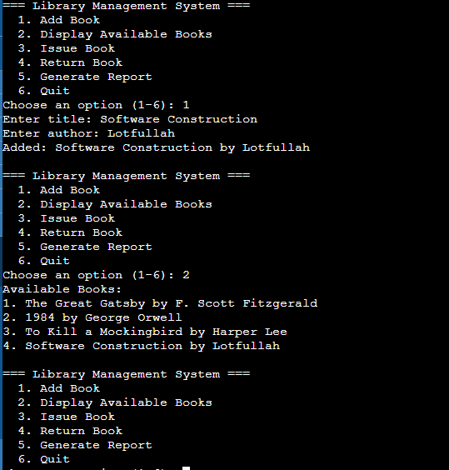
Screenshot

